**Step 1.1.2.2:**

**Step 1.1.3.2:**

**Step 1.1.3.4:**

**

**Step 4.1.1:**

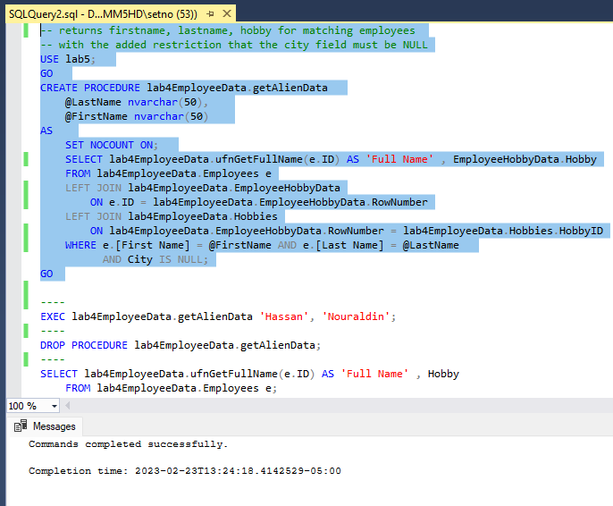

**Step 4.2.1.2-1:**

